A tutorial of TSPTFBS

In this paper, we analyzed a large-scale DAP-seq TFBS dataset (265 TFs) in Arabidopsis thaliana with the advanced DeepCNN model, and we successfully built 265 Arabidopsis TFBS prediction models for practical needs of the plant community.

Here we provide a docker container for convenient using of our trained 265 Arabidopsis TFBS prediction models. We use docker to encapsulate the app and provide docker image. The operation steps are as follows:

**Step 1: Download docker images with command line:**

docker pull vanadiummm/tsptfbs:v1.0

then with command <docker images> you can see the image in your path.



**Step 2: Run the image in docker container with command line:**

docker run -p 8000:80 -d vanadiummm/ tsptfbs:v1.0

The parameter “-p” point out the port to run the web app, and the 8000 port can be changed to any possible port, but the 80 port should always be fixed.

**Step 3: Predict TFBSs with the docker container:**

Open web browser, and type 127.0.0.1 or server IP in the web address bar.

1. Click Operate Frame of Predictions;
2. Click POST;
3. Click Try it out;

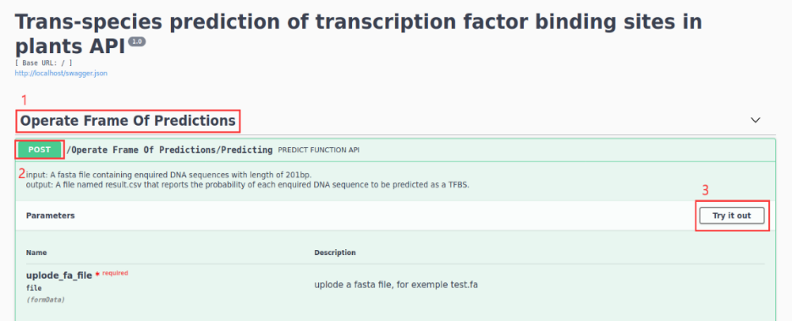

1. Upload a fasta file containing enquired DNA sequences;
2. Click Execute

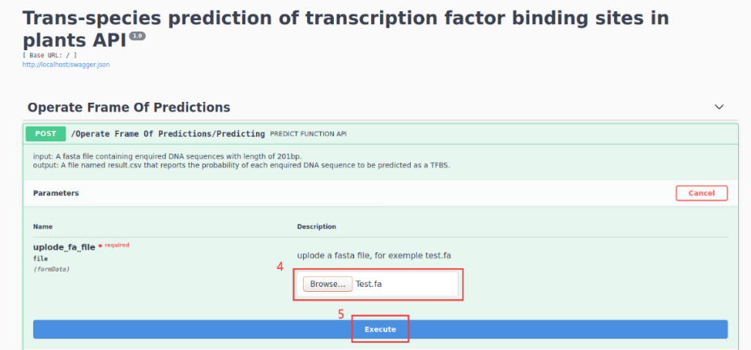

1. Click Download file to get the prediction results

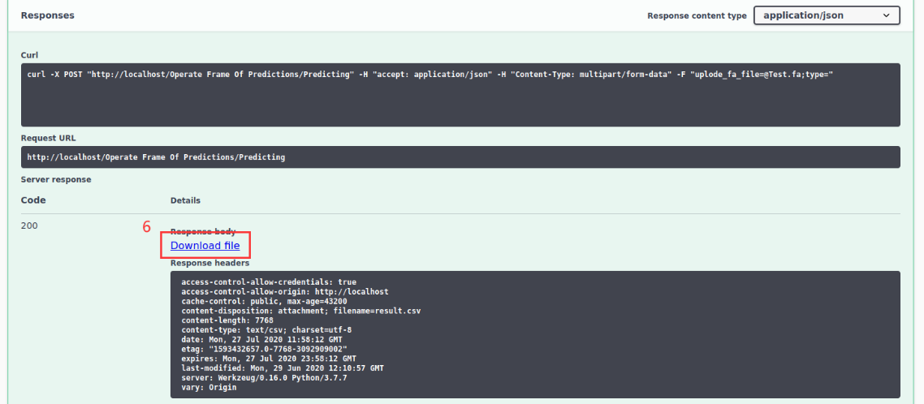

1. Open results.csv

